**Design Thinking Project Workbook**

**Don't find customers for your product but find products for your customers**

**1. Team**

**Team Name: AI Architects**

**Team Logo (if any):**

**Team Members:**

1. SUMITH, Executer,
2. M .UDAY KIRAN , Team Lead
3. ADITHYA, Ideate

**2. Problem/Opportunity Domain**

**Domain of Interest:** The Domain of Interest for our project would be the **Travel and Hospitality Industry.** This domain includes various aspects of travel, tourism, and customer service, where AI/ML can be applied to enhance the user experience.

**Description of the Domain**: The Travel and Hospitality domain encompasses all services and activities related to travel, tourism, and customer experiences, ranging from booking flights and hotels to providing local recommendations. With the rise of technology and digital services, this industry is increasingly adopting Artificial Intelligence (AI) and Machine Learning (ML) to enhance customer experiences through personalized, efficient, and real-time assistance.

**Why did you choose this domain?** The main reason for us to choose this particular domain is the Love for Innovationwherein This domain allows for innovative solutions, from improving customer experiences to tackling sustainability challenges. The dynamic nature of this industry keeps me motivated to explore creative solutions.

**3. Problem/Opportunity Statement**

* **Problem Statement:** Travelers often struggle to find personalized travel itineraries that match their preferences, budget, and travel style.

**Problem Description:** Travelers often face challenges in creating personalized travel itineraries that cater to their specific preferences, budget, and travel style. While the travel industry offers a wide array of options, the abundance of choices can make the planning process overwhelming, time-consuming, and stressful for many.

**Context (When does the problem occur):** Overwhelming Options, Budget Constraints, Lack of Local Knowledge, Unique Preferences, Time Sensitivity.

**Customers (Who has the problem most often):** Leisure Travelers like the Individuals or families planning vacations, Travel Agencies and Tour Operators etc.

**Emotional Impact (How does the customer feel):** Travelers experience a variety of emotions and frustrations due to the challenge of finding personalized travel itineraries, like Excitement for Travel, Satisfaction When Successful, and Frustrations like Overwhelm from Too Many Options, Difficulty Balancing Budget and Preferences etc.

**Quantifiable Impact (What is the measurable impact):** The measurable effects of the problem where travellers struggle to find personalized travel itineraries include both financial losses and time wasted, impacting both individuals and businesses. Example Time Wasted in Trip Planning, Higher Travel Costs etc.

**Alternative Shortcomings (What are the disadvantages of the alternatives): The limitations or downsides of the current solutions customers use.**

**Any Video or Images to showcase the problem: The evidence in the form of video or image).**

**Provide link if available**

**NO**

**3. Addressing SDGs**

**Relevant Sustainable Development Goals (SDGs): The relevant SDGs for the problem statement are:**

SDG 8: Decent Work and Economic Growth

SDG 11: Sustainable Cities and Communities

**How does your problem/opportunity address these SDGs?**

1. **SDG 8: Decent Work and Economic Growth**

* Promoting Tourism: The travel and tourism industry is a major driver of economic growth. Personalized travel itineraries can lead to increased customer satisfaction, encouraging more travel and tourism activities, which supports local economies and businesses.
* Sustainable Tourism: Providing personalized itineraries can promote sustainable tourism practices by recommending eco-friendly accommodations and activities, helping to reduce the environmental impact of tourism.

1. **SDG 11: Sustainable Cities and Communities**

* **Promoting Local Culture and Communities**: Personalized travel itineraries that emphasize local, community-based experiences can contribute to the cultural preservation and sustainable development of cities and communities, reducing the strain on over-touristed areas.

**4. Stakeholders**

Answer these below questions to understand the stakeholder related to your project

1. **Who are the key stakeholders involved in or affected by this project?**

The key stakeholders involved in or affected by a project aimed at improving personalized travel itineraries include Travelers, Travel and Tourism Companies, Technology Providers, Travel Influencers and Bloggers, Investors and Stakeholders in Travel Platforms.

1. **What roles do the stakeholders play in the success of the innovation?**

Each stakeholder contributes to shaping, supporting, or benefiting from the system in the following ways:

1. Travelers: Contribution to Success like User Feedback
2. Travel Agencies and Tour Operators: Personalized Offerings, Platform Collaboration.
3. Technology Providers: AI and Machine Learning Development, Cloud Infrastructure Support, Continuous Innovation.
4. Investors and Stakeholders in Travel Platforms: Business Growth Support.
5. **What are the main interests and concerns of each stakeholder?**
6. **Travelers:**

**Interests**: Easy, convenient, and personalized travel experiences that match preferences, budget, and style. Accurate recommendations and seamless booking processes.

**Concerns**: Poor personalization, time wasted on irrelevant options, and privacy issues with personal data.

**2. Travel Agencies and Tour Operators:**

* **Interests**: Increased customer satisfaction, improved customer retention, and access to a wider audience through the platform.
* **Concerns**: Competition from direct online platforms, the need to integrate seamlessly with new technology, and managing customer expectations.

3. **Technology Providers:**

* **Interests**: Successful implementation of AI and machine learning models to provide accurate and personalized recommendations. Driving adoption of cloud and infrastructure solutions.
* **Concerns**: Scalability issues, data security risks, and challenges in adapting to rapid changes in the tourism industry.

### **4.Investors and Stakeholders in Travel Platforms**

* **Interests**: Maximizing return on investment, platform growth, and high user adoption rates.
* **Concerns**: Poor performance, scalability issues, or market competition reducing profitability.

1. **How much influence does each stakeholder have on the outcome of the project?**

• **High Influence**: Travelers (Primary Users), Technology Providers, Investors

• **Medium Influence**: Travel Agencies and Tour Operators, Travel and Tourism Companies, DMOs, Governments, Travel Influencers

• **Low to Medium Influence**: Environmental Groups, Local Communities and Businesses

1. **What is the level of engagement or support expected from each stakeholder?**

• **High Engagement**: Travelers (Primary Users), Travel Agencies, Technology Providers, Investors

• **Medium Engagement**: Travel and Tourism Companies, DMOs, Governments, Influencers

• **Low to Medium Engagement**: Environmental Groups, Local Communities

1. **Are there any conflicts of interest between stakeholders? If so, how can they be addressed?**

Yes, there can be potential conflicts of interest between stakeholders.

* **Collaborative Dialogue**: Regular meetings and open communication between stakeholders to discuss concerns, interests, and goals.
* **Clear Guidelines and Policies**: Establish transparent policies for data use, pricing, and sustainability to align stakeholder actions with platform goals.
* **Incentives for Cooperation**: Offer rewards or recognition to stakeholders who contribute to mutually beneficial outcomes (e.g., sustainability awards for tourism companies, privacy assurance for users).
* **Customization and Flexibility**: Provide personalized options for travellers while offering flexibility to service providers, allowing for adaptability and compromise.
* By addressing these conflicts with thoughtful solutions, the project can balance the needs of all stakeholders and create a more sustainable, user-friendly, and profitable platform.

Top of Form

Bottom of Form

1. **How will you communicate and collaborate with stakeholders throughout the project?**

* Effective communication and collaboration will rely on a multi-tiered approach, involving structured meetings, digital platforms, workshops, and continuous feedback. Each stakeholder will receive targeted information and opportunities for collaboration to ensure the project aligns with everyone’s interests and objectives.

1. **What potential risks do stakeholders bring to the project, and how can these be mitigated?**

• **Clear Communication**: Ensure that all stakeholders understand the project's goals, guidelines, and progress.

• **Incentive Alignment**: Align stakeholder incentives with project success, ensuring that stakeholders are motivated to collaborate effectively.

• **Proactive Engagement**: Actively engage stakeholders throughout the project lifecycle, ensuring that concerns are addressed before they become major issues.

• **Compliance and Adaptability**: Stay adaptable and compliant with regulatory, environmental, and market changes to ensure long-term project viability.

**5. Power Interest Matrix of Stakeholders**

**Power Interest Matrix: Provide a diagrammatic representation of Power Interest Matrix**

| High Power, High Interest | High Power, Low Interest

High Power |-----------------------------|---------------------------

| Travel Authorities | Local Authorities

| Major Investors | Lobby Groups

| Key Business Partners | Major Competitors

|

Low Power |-----------------------------|---------------------------

| Keep Informed | Monitor

| Tourists/Travelers | General Public

| Employees | Suppliers

| Local Communities | Media

|

| Low Interest | High Interest

|-----------------------------|---------------------------

* High Power, High Interest: [Government Regulatory Bodies, Major Investors, Key Business Partners]
* High Power, Low Interest: [Local Authorities, Lobby Groups, Major Competitors]
* Low Power, High Interest: [Customers/Travelers, Local Communities, Employees]
* Low Power, Low Interest: [General Public, Suppliers, Media]

**6. Empathetic Interviews**

**Conduct Skilled interview with at least 30 citizens/Users by asking open ended questions (What, why/How etc) and list the insights as per the format below**

|  |  |  |
| --- | --- | --- |
| **I need to know**  **(thoughts, feelings, actions)** | **Questions I will ask**  **(open questions)** | **Insights I hope to gain** |
| Thoughts | What do you usually think about when planning a trip? | Common thought processes around trip planning and expectations of automation. |
|  | How do you feel about using chatbots for booking travel? | Understanding perceptions of chatbot usage in travel bookings. |
|  | What information do you usually look for first when planning a trip? | Types of information users prioritize (e.g., cost, convenience, destination info). |
| Feelings | How do you feel when you're interacting with travel planning tools? | Emotional responses to current tools and potential points for improvement. |
|  | Can you describe a frustrating experience you’ve had while planning travel? | |  | | --- | | Pain points in the travel planning process. |  |  | | --- | |  | |
|  | How would you feel if a chatbot could handle most of the planning for you? | Comfort level with automated travel planning and trust in chatbots. |
| Actions | How would you like a travel chatbot to assist you during your trip? | Common methods of booking and preferences for interaction (e.g., online, agency). |
|  | How do you prefer to manage unexpected changes during a trip? | User preferences for real-time trip support and handling contingencies. |
|  |  |  |

**SKILLED INTERVIEW REPORT**

|  |  |  |
| --- | --- | --- |
| **User/Interviewee** | **Questions Asked** | **Insights gained (NOT THEIR ANSWERS)** |
| Arjun M., Student | How do you feel about using chatbots for booking travel? | Young users are generally open to using chatbots, especially if they streamline the booking process. |
| |  | | --- | | Priya S., Professional |  |  | | --- | |  | | What do you usually think about when planning a trip? | Users often prioritize affordability and convenience when planning trips. |
|  |  |  |
|  |  |  |
|  |  |  |

**Key Insights Gained:**

* **Insight 1:** Young users are generally open to using chatbots, especially if they streamline the booking process.
* **Insight 2:** Users often prioritize affordability and convenience when planning trips.

**Empathy Map**

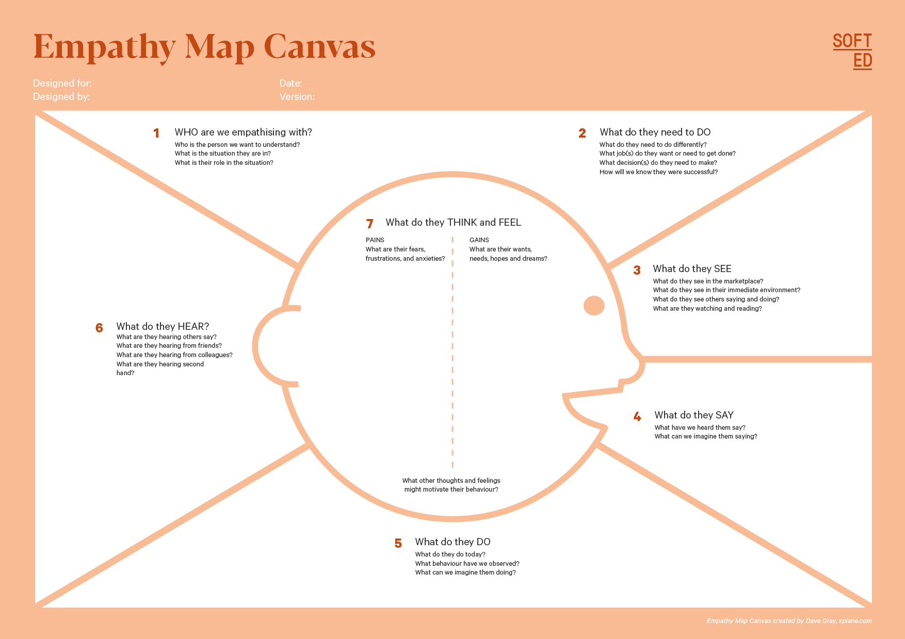

Your Answer:

Your Answer:

Who is your Customer Segment:

Idea/Innovation Title:

Designed By:

Date of Submission:

Your Answer:

Your Answer:

Your Answer:

Your Answer:

Your Answer:

Your Answer:

Your Answer:

**7. Empathy Map**

1. **Who is your Customer?**

**Description: This is where you specify the customer or user you are empathizing with. It could be a specific user persona or a general user segment.**

**Key points:**

* **Define the customer profile clearly (e.g., age, profession, interests).**
* **State their goals and needs related to the innovation or product.**
* **Context in which the user will interact with your solution.**

1. **Who are we empathizing with?**

**Description: This area helps you define who the user is, what their situation looks like, and what role they play. It emphasizes understanding the user’s perspective in depth.**

**Key points:**

* **Define the user's characteristics (e.g., personality, values, and responsibilities).**
* **State the user's goals and challenges in their environment.**
* **What is the user's broader situation (professionally or personally)?**

1. **What do they need to DO?**

**Description: This section identifies what actions or tasks the user needs to perform. It helps highlight the expectations and demands the user faces.**

**Key points:**

* **Clarify the tasks or actions the user needs to complete.**
* **What decisions do they need to make?**
* **How do they define success or failure in their tasks?**

1. **What do they SEE?**

**Description: This focuses on the visual stimuli or environment that the user interacts with. It's important to consider what users see in their immediate surroundings and in their larger world.**

**Key points:**

* **What do users see in their physical and digital environment?**
* **What trends or competitors do they notice?**
* **How do these visual elements influence their behavior?**

1. **What do they SAY?**

**Description: This section captures what the user might say in public, such as comments or feedback they give in conversations or on social media.**

**Key points:**

* **What might users express openly in conversation about their problems?**
* **How do they express their goals or frustrations?**
* **What are their words during customer interviews or feedback?**

1. **What do they DO?**

**Description: This section focuses on what the user does, the actual behaviors they exhibit, and actions they take in different situations.**

**Key points:**

* **What observable actions do users take?**
* **What habits or routines do they follow?**
* **What might users do to try and solve their problems?**

1. **What do they HEAR?**

**Description: This addresses what information the user receives from external sources, such as colleagues, media, or industry trends. It helps map the influences surrounding the user.**

**Key points:**

* **What are they hearing from peers, mentors, or the industry?**
* **What media or channels of information are they exposed to?**
* **Are there any strong influencers guiding their behavior?**

1. **What do they THINK and FEEL?**

**Description: This is one of the most insightful sections, addressing the internal emotions, concerns, and motivations of the user. It helps identify their deep-rooted feelings.**

**Key points:**

* **What are their fears, worries, and anxieties?**
* **What are their motivations and desires?**
* **How do their thoughts and feelings align with their actions?**

1. **Pains and Gains**

**Description: This section focuses on the user’s frustrations and their desired outcomes. It helps to frame the user’s challenges (pains) and the benefits they seek (gains).**

**Key points:**

* **What are the user’s main pain points?**
* **What would make their life easier or more fulfilling?**
* **What benefits do they hope to achieve from your product or solution?**

**8. Persona of Stakeholders**

**Stakeholder Name:**

**Demographics: Key characteristics of your target audience, such as age, gender, income, and location.**

**Goals: What the stakeholders or customers want to achieve in relation to the innovation.**

**Challenges: The obstacles or difficulties faced by stakeholders that the innovation aims to address.**

**Aspiration: The long-term desires or dreams of your target audience related to the innovation.**

**Needs: The essential requirements of your customers or stakeholders that must be met.**

**Pain Points: Specific problems or frustrations experienced by the target audience.**

**Storytelling: A narrative that highlights the journey of the stakeholder or customer, illustrating the problem and how the innovation can solve it.**

**Sample:**

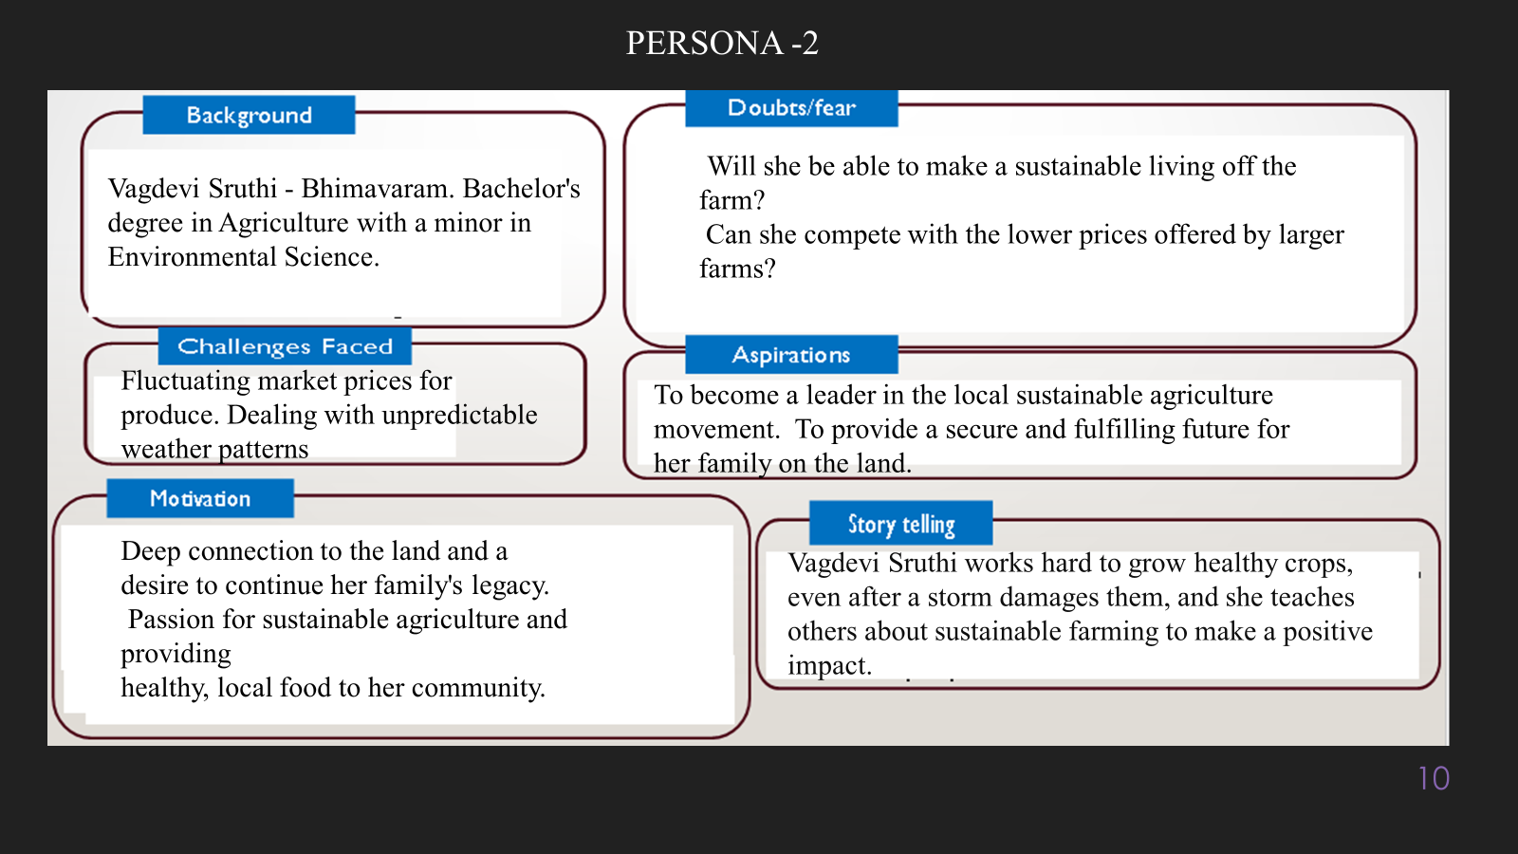

**10. Look for Common Themes, Behaviours, Needs, and Pain Points among the Users**

Analyse the data from your affinity diagram to uncover recurring patterns among your users, helping you better understand their expectations and challenges.

**Common Themes: Identify broad ideas or issues that repeatedly appear across different groups in your affinity diagram.**

**Common Behaviors: Observe how users consistently act or respond in relation to the problem or product throughout their journey.**

**Common Needs: Pinpoint essential requirements or desires that many users share, highlighting what they need for a better experience.**

**Common Pain Points: Look for frustrations or obstacles that frequently hinder the user experience, which your project can address.**

**12. Define Needs and Insights of Your Users**

**User Needs: Define the core requirements your users have in relation to the problem or product. These could be functional, emotional, or societal needs that your solution must address.**

**User Insights: Summarize the key understandings or observations you've uncovered about your users' behaviors, motivations, and pain points. These insights provide a deeper understanding of why users behave the way they do and what drives their decisions.**

**13. POV Statements**

**POV Statements:**

* [User] needs a way to [need] because [insight].

|  |  |  |  |
| --- | --- | --- | --- |
| PoV Statements  (At least ten) | Role-based or Situation-Based | Benefit, Way to Benefit,  Job TBD,  Need (more/less) | PoV Questions  (At least one per statement) |
| (Erase this example) When I drive to work, I want to avoid traffic jams so I don’t get in trouble with my boss for being late. | Situation | Way to Benefit | What can we design that will enable drivers to avoid traffic jams?  What can we design that will enable workers to avoid getting in trouble for being late to work? |
|  |  |  |  |
|  |  |  |  |
|  |  |  |  |
|  |  |  |  |

**14. Develop POV/How Might We (HMW) Questions to Transform Insights/Needs into Opportunities for Design**

Turn your user needs and insights into actionable opportunities by framing them as "How Might We" (HMW) questions. These questions will spark creative problem-solving and guide your innovation process.

1. **How Might We: Based on the needs and insights you've identified, create open-ended questions starting with "How might we...?" These questions should aim to solve user pain points, enhance the experience, or address specific needs.**

**Examples:**

* **User Need: "Users need a quicker way to access customer support."**
  + **HMW Question: "How might we create a more efficient and accessible customer support system?"**
* **Insight: "Users feel overwhelmed by too many options."**
  + **HMW Question: "How might we simplify decision-making for our users?"**

**Task:**

**Write 3-5 "How Might We" questions based on your analysis of user needs and insights. These questions should challenge you to think of innovative solutions that can address user problems in meaningful ways.**

**This task encourages participants to think creatively about solving user problems, transforming challenges into opportunities for innovation.**

|  |  |
| --- | --- |
| User Need/Insight | "How Might We" Question |
| [State the user need or insight clearly] | **How might we... [formulate an open-ended question to address the need or insight]?** |

**16. Crafting a Balanced and Actionable Design Challenge**

The Design Challenge Should Neither Be Too Narrow Nor Too Broad and It Should Be an Actionable Statement with a quantifiable goal. It should be a culmination of the POV questions developed.

**Design Challenge:** [Actionable Statement]

**17. Validating the Problem Statement with Stakeholders for Alignment**

Ensure your problem statement accurately represents the needs and concerns of your stakeholders and users. This involves gathering feedback from these groups to confirm that the problem is relevant and significant from their perspective. By validating early, you can refine the problem statement to better align with real-world challenges, ensuring your solution addresses the correct issues.

**Validation Plan:**

**Stakeholder/User Feedback (Min. 10 Stakeholders/Experts):**

|  |  |  |  |
| --- | --- | --- | --- |
| Stakeholder/User | Role | Feedback on Problem Statement | Suggestions for Improvement |
| [Name/Group] | **[Role/Title]** | **[Does the problem resonate with them? Why or why not?]** | **[Suggestions for refining the problem statement]** |
| [Name/Group] | **[Role/Title]** | **[Does the problem resonate with them? Why or why not?]** | **[Suggestions for refining the problem statement]** |

**18. Ideation**

**Ideation Process:**

|  |  |  |  |
| --- | --- | --- | --- |
| Idea Number | Proposed Solution | Key Features/Benefits | Challenges/Concerns |
| Idea 1 | **[Brief description of solution]** | **[What are the key benefits of this solution?]** | **[What challenges or concerns exist?]** |
| Idea 2 | **[Brief description of solution]** | **[What are the key benefits of this solution?]** | **[What challenges or concerns exist?]** |
| Idea 3 | **[Brief description of solution]** | **[What are the key benefits of this solution?]** | **[What challenges or concerns exist?]** |
| Idea 4 | **[Brief description of solution]** | **[What are the key benefits of this solution?]** | **[What challenges or concerns exist?]** |
| Idea 5 | **[Brief description of solution]** | **[What are the key benefits of this solution?]** | **[What challenges or concerns exist?]** |

**18. Idea Evaluation**

Evaluate the Idea based on 10/100/1000 grams

|  |  |  |  |  |
| --- | --- | --- | --- | --- |
| Idea | Impact (10/100/1000 grams) | Feasibility (10/100/1000 grams) | Alignment (10/100/1000 grams) | Total Weight |
| Idea 1 | **[Assign weight]** | **[Assign weight]** | **[Assign weight]** | **[Sum of weights]** |
| Idea 2 | **[Assign weight]** | **[Assign weight]** | **[Assign weight]** | **[Sum of weights]** |
| Idea 3 | **[Assign weight]** | **[Assign weight]** | **[Assign weight]** | **[Sum of weights]** |
| Idea 4 | **[Assign weight]** | **[Assign weight]** | **[Assign weight]** | **[Sum of weights]** |
| Idea 5 | **[Assign weight]** | **[Assign weight]** | **[Assign weight]** | **[Sum of weights]** |

**Example:**

|  |  |  |  |  |
| --- | --- | --- | --- | --- |
| Idea | Impact (10/100/1000 grams) | Feasibility (10/100/1000 grams) | Alignment (10/100/1000 grams) | Total Weight |
| Idea 1 | **1000** | **100** | **1000** | **2100** |
| Idea 2 | **100** | **1000** | **100** | **1200** |
| Idea 3 | **100** | **100** | **100** | **300** |

Further, use solution concept form to scrutinize the idea

**Solution Concept Form**

**1. Problem Statement:**

* **[State the validated problem your solution addresses.]**

**2. Target Audience:**

* **[Describe the main users or customers who will benefit from this solution.]**

**3. Solution Overview:**

* **[Provide a brief description of the solution concept.]**

**4. Key Features:**

| **Feature** | **Description** |
| --- | --- |
| **Feature 1** | **[Briefly describe the main feature of your solution]** |
| **Feature 2** | **[Briefly describe another key feature]** |
| **Feature 3** | **[Briefly describe a third key feature]** |

**5. Benefits:**

| **Benefit** | **Description** |
| --- | --- |
| **Benefit 1** | **[What value does this solution bring?]** |
| **Benefit 2** | **[How does this solution solve the problem?]** |
| **Benefit 3** | **[What makes this solution stand out?]** |

**6. Unique Value Proposition (UVP):**

* **[Summarize why this solution is unique and why it will appeal to your target audience.]**

**7. Key Metrics:**

| **Metric** | **Measurement** |
| --- | --- |
| **Metric 1** | **[What is the key metric to measure success?]** |
| **Metric 2** | **[What is another key metric for tracking progress?]** |

**8. Feasibility Assessment:**

* **[Provide a brief evaluation of how achievable or practical this solution is (consider resources, time, and technology).]**

**9. Next Steps:**

* **[Outline the next steps for further developing or prototyping this solution.]**